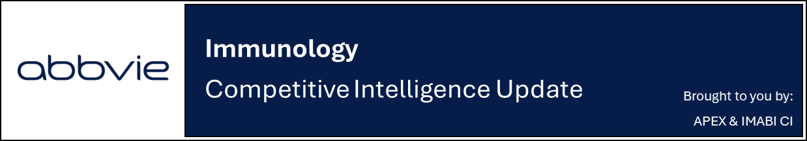
Positive topline results from Ph3b TOGETHER-PsA trial for Taltz + Zepbound

Company: Lilly  Drug: Taltz (ixekizumab, SC IL-17A inhibitor) + Zepbound (tirzepatide, SC GIP/GLP-1 agonist) | Date: January 8^{th,} 2026  Source(s): Press Release
What happened:
- Lilly announced positive 36-week topline results from the open label Phase 3b TOGETHER-PsA trial evaluating the concomitant use of Taltz and Zepbound compared to Taltz monotherapy in adults with active PsA and obesity or overweight with at least one weight-related condition
  - Primary endpoint: 31.7% of Taltz+Zepbound patients achieved ACR50 + weight reduction of at least 10%, compared to 0.8% on Taltz monotherapy (p <0.01)
  - Key secondary endpoint: 33.5% vs. 20.4% of patients achieved ACR50 (p<0.05), “demonstrating that treatment of obesity or overweight with Zepbound reduced the burden of PsA”
  - Adverse events consistent with known safety profile of each medicine

Impact (CI PoV): MEDIUM
- With these data, Lilly is positioning Taltz as the first biologic to demonstrate incremental efficacy when combined with an incretin therapy in a dedicated clinical trial, with the potential to raise the standard of care in PsA
  - Recall Lilly has messaged the impact of obesity on PsD disease activity at its unbranded booths and symposiums, while co-promoting Taltz and Zepbound with branded content at recent dermatology and rheumatology conferences

Why it matters (CI Insights in blue italics):
- The positive results from the TOGETHER-PsA trial underscore the potential of an integrated treatment approach in the management of PsA patients who also suffer from overweight or obesity and additional co-morbidities
  - Lilly highlights that an estimated 65% of adults with PsA in the US also have obesity (BMI ≥30 kg/m²) or overweight (BMI 27-29.9 kg/m²) with at least one additional weight-related comorbidity
  - Notably, the study included patients with a high disease burden at baseline and an average BMI of 37.6 kg/m² across both arms, and >60% of patients had prior experience with one or more advanced therapies, reflecting a difficult-to-treat patient population
- These are the first results from a controlled study to evaluate an incretin therapy used with a PsA biologic that showed positive disease outcomes for patients suffering with PsA and overweight
- Lilly plans to present these results at an upcoming medical meeting and discuss with regulators
  - Although open-label data is typically insufficient for label expansion, Lilly may be consulting with regulators to obtain guidance on permissible promotional claims

Tell me more:
- The Phase 3b TOGETHER-PsA is a 52-week, randomized, multi-center, open-label study assessing the efficacy and safety of Taltz and Zepbound compared with Taltz alone in adult participants with active PsA and obesity or overweight
  - 271 participants were randomized 1:1 to receive either Taltz alone or concomitantly with Zepbound, both administered subcutaneously
  - Inclusion criteria included participants with a BMI ≥30 kg/m², or ≥27 to <30 kg/m² with at least one weight-related comorbidity
  - Primary endpoint is ACR50 response and ≥10% weight reduction at Week 36
- Safety:
  - The most common AEs occurring in ≥5% of participants:
    - Taltz + Zepbound arm: nausea, diarrhea, constipation and injection site reactions
    - Taltz monotherapy: injection site reactions and upper respiratory tract infections
- Future catalysts:
  - PsO: Phase 3 TOGETHER-PsO topline results in 1H 2026
  - Phase 4 TOGETHER AMPLIFY-PsA and TOGETHER AMPLIFY-PsO open-label, single arm trials evaluating Taltz + Zepbound in PsA or PsO patients with obesity or overweight are also ongoing (Primary Completion Date: November 2027/ May 2028)

For questions, please reach out to:
 | Dermatology | Rheumatology | Gastroenterology
APEX (US/PCS) | Chanda Bhat | Bethany Christmann | Luke Versten
IMABI (International/ Affiliates) | Priti Anand | Irene Knorn | Priti Anand

Invite your colleagues to inVision | Manage Email Preferences | Unsubscribe

This document contains competitive intelligence collected via APEX/IMABI approved methods or vendors. We collect competitive intelligence consistent with industry standards and AbbVie policy. Not for commercial field distribution. Please reach out to Legal or OEC with any questions.

